Using ‘T-Labs’ to find transformative pathways to equitable and sustainable utilisation of Kenya’s Yala and Kingwal wetlands
Authors: Prof Nzula Kitaka, Nora Ndege, Risper Ondiek, Valerie Nyanaro and Prof Julius Kipkemboi
Wetlands are valuable ecosystems to humanity. They provide clean water for domestic use, construction materials, and food. Wetlands also protect us from flooding events and help us to combat climate change. In Kenya, wetlands such as Yala, in Siaya and Busia Counties and Kingwal, in Nandi County, not only support the livelihoods and well-being of the communities neighbouring them but are also important bird and biodiversity areas. The wetlands provide clean water for domestic use, water for irrigation, fish for food and commercial use, artisanal papyrus products, and grass for construction. They also reduce pollution of Lake Victoria and mitigate flooding.
The wetlands also host a variety of biodiversity. Both wetlands are renowned breeding sites for the Sitatunga antelope (Tragelaphus spekii) that is both rare and endangered. Yala wetland is recognized as an Important Bird Area (IBA), hosting at least 172 bird species, some of which are globally threatened or biome-restricted including the Papyrus Yellow Warbler , Papyrus Gonolek and White-winged warbler. Various satellite lakes including Kanyaboli, Sare, Namboyo, and Bob are also important refuges for endemic Lake Victoria cichlids.
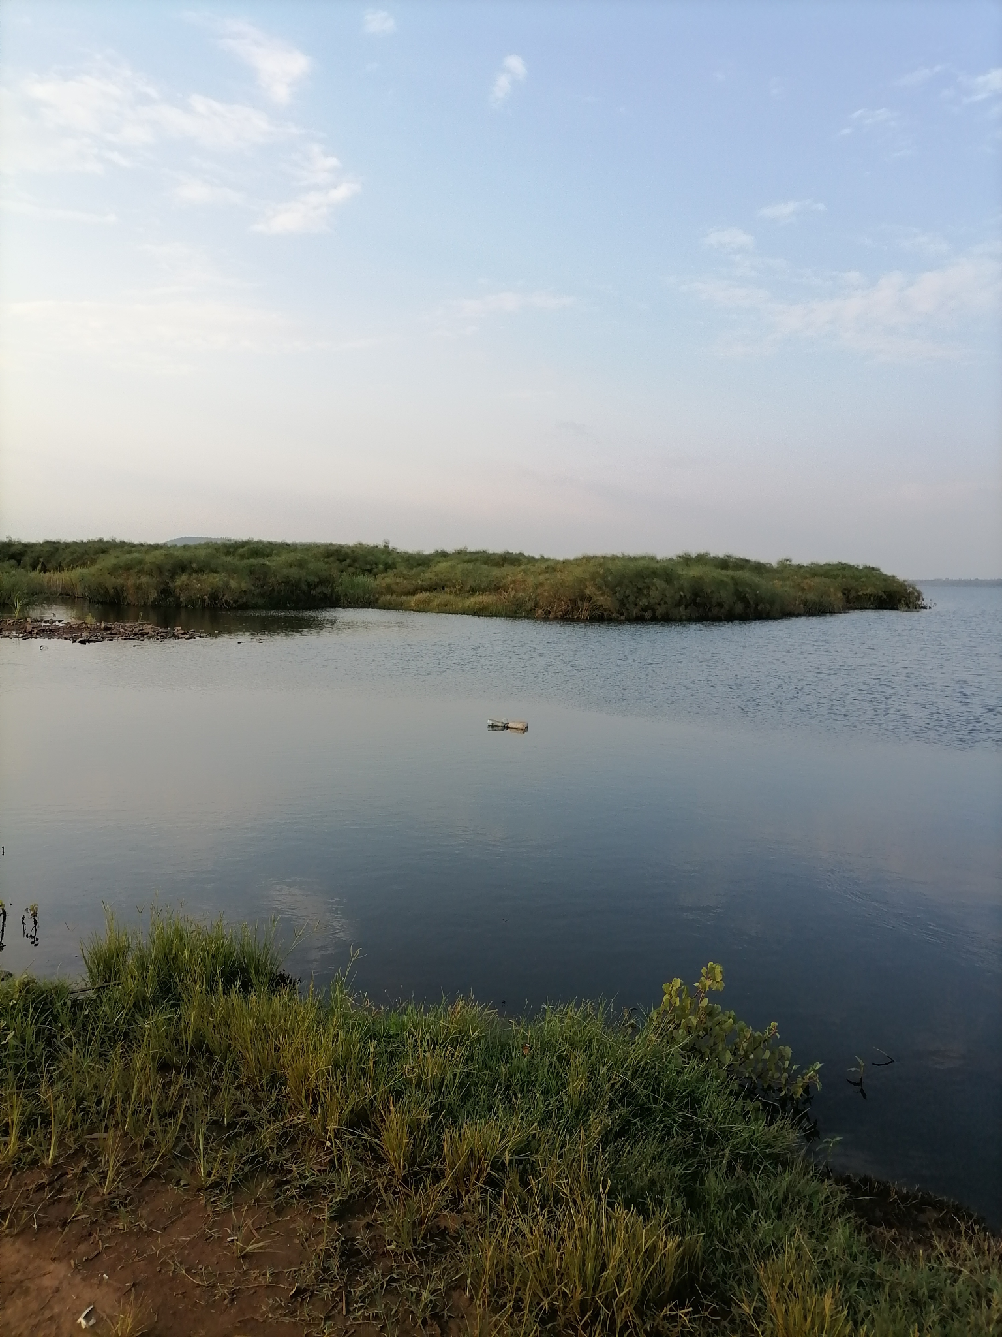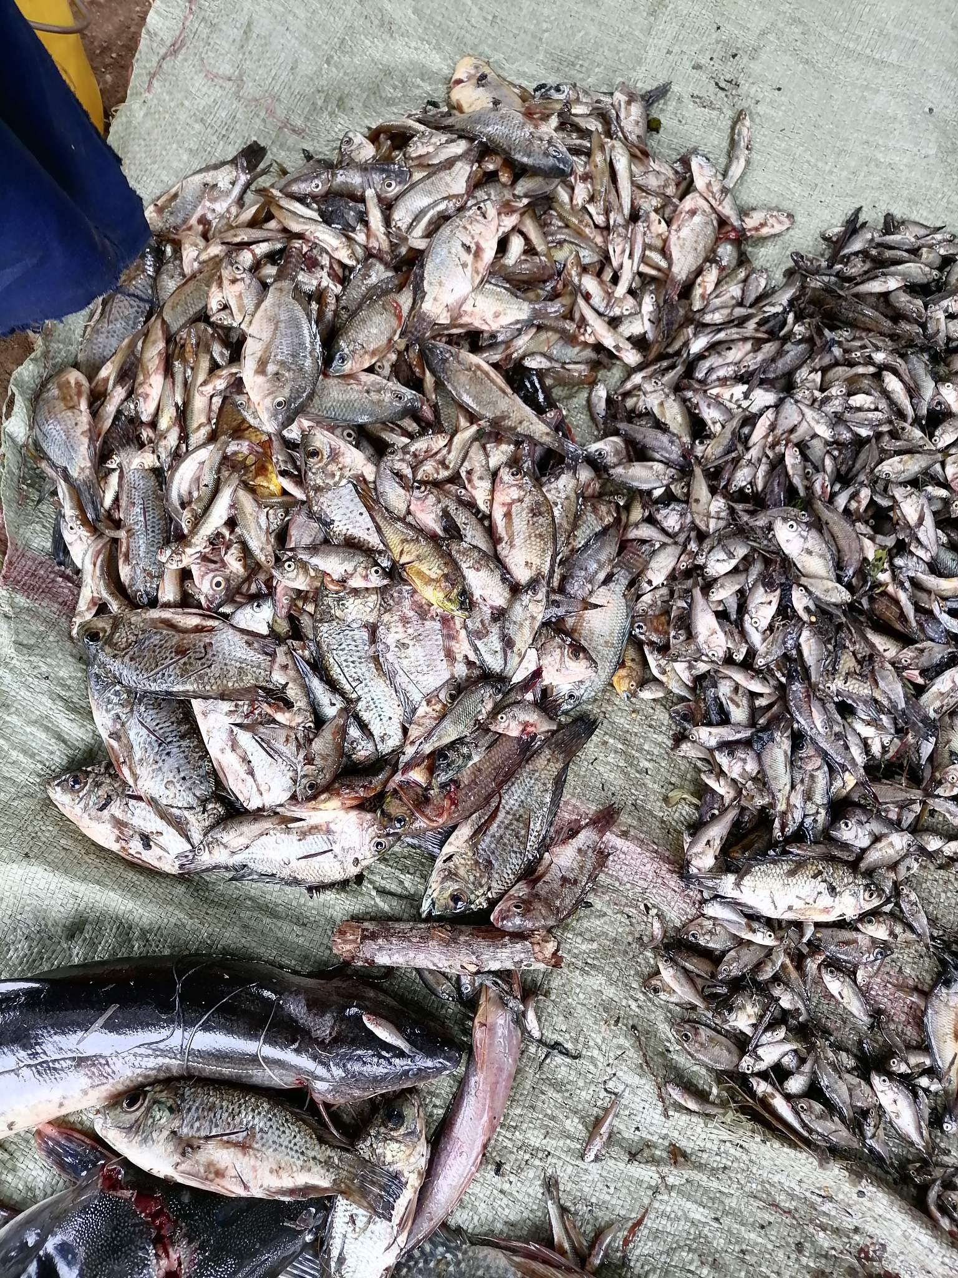
Photo showing clear water due to wetland filtration of sediments and fish from Yala wetland (Photos by Risper Ondiek)
The challenge
As human populations increase, the demand for resources from wetlands is increasingly becoming unsustainable because of direct and heavy dependency on the benefits people derive from them, which are called ecosystem services. Wetlands such as Yala and Kingwal are facing unprecedented encroachment for agriculture. In Yala wetland, the encroachment is not only unsustainable but also inequitable. By 2014, 21% of the wetland had been converted to small and large-scale agricultural farming production.
Small-scale agriculture is practised by the local community for subsistence purposes, while large-scale agriculture is practised by a private developer, Lake Agro Kenya Limited, for commercial sugarcane production. From 1,951 ha in 2014, the private investor has been leased an additional land of 3,000 ha in the wetland (on the Siaya County side) by the National Lands Commission for 66 years. The local community, however, has not been allocated additional land for farming, even though Yala wetland is thought to be a community owned land.
The County Government of Siaya has also reported that the leasing of the land to the agriculture company is unconstitutional because it was signed between the ministry responsible for lands at the national government and the private developer instead of between the Siaya county government and the National Lands Commission.
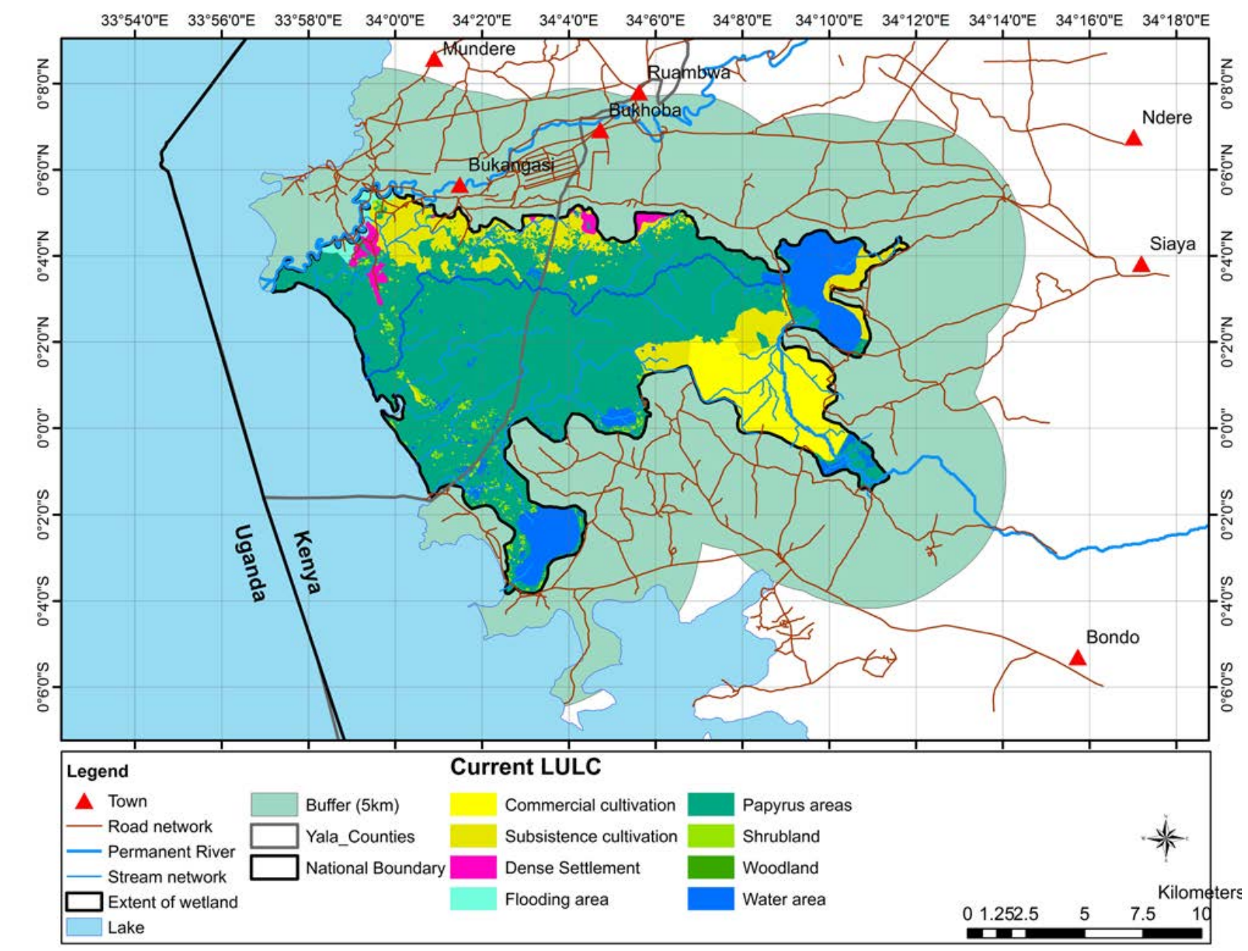
Land use/cover in Yala wetland in 2014. Source
What has been done?
Several efforts have been developed over recent times to deal with the challenges to combat unsustainable use of the wetland and the inequities in terms of access and the distribution of benefits. These have been led by communities, government and development partners. However, the inequities still persist.

1. Community-driven initiatives
In Yala wetland, the local community has been working closely with the NGO, Nature Kenya on equitable allocation of Yala wetland for farming. During public hearings conducted by the National Lands Commision in 2022, the community together with civic and governmental organizations such as Kenya Wildlife Service and National Environment Management Authority objected to the proposed land allocation to the private investor.
Also, Yala Ecosystem Site Support Group, a community-based organization focusing on wetland conservation, has taken initiative to promote alternative livelihood opportunities such as bee and poultry keeping to reduce anthropogenic pressure and overdependence on the wetland. In Kingwal, some community members have taken personal initiative to restore some parts of the wetland and engage in bee keeping as an alternative livelihood.
2. Donor driven initiatives
In Yala wetland, donors and development partners such as Darwin Initiative, PREPARED Program of USAID/East Africa and MacArthur Foundation provided funding that facilitated development of Yala Delta Land Use Plan and the associated Strategic Environmental Assessment by Nature Kenya. In Kingwal wetland, the Food and Agriculture Organization working in partnership with the County Government of Nandi and the Kingwal Water Users Association have taken initiative to restore some parts of the wetland.

3. Policy-level initiatives
At county level, the County Government of Nandi has enacted a bill on wetland management and conservation (the Nandi County Wetland Management and Conservation Act, 2020) to facilitate better wetland management of all wetlands in the county. Also, Kingwal wetland has a management plan meant to ensure its sustainable utilisation. In Siaya and Busia Counties, Yala wetland has a land use plan that was approved by the County Assembly of Busia in 2023. The County Assembly of Siaya is in the process of approving this plan, which advocates for a balance between agricultural development and conservation of the wetland. In the meantime, both County Governments have signed a joint communiqué on the management of Yala wetland.
At national level, there are existing legal and policy frameworks that intend to enforce the sustainable management of natural resources including wetlands, including the Environmental Management and Coordination (Amendment) Act (EMCA) of 2015. Also, Kenya as a contracting party to the Ramsar Convention on Wetlands, is obligated to conserve and wisely use all wetlands. Despite legal and institutional arrangements, wetland degradation continues unabated.
Given the above mentioned efforts, our research project, Water Transformation Pathways Planning (Trans-Path-Plan) Kenya Node aims to pro-actively influence transformations in Kingwal and Yala wetlands away from undesirable trajectories towards more equitable and sustainable directions to ensure multiple ecosystem services provision. We will carry out Transformations Laboratories (T-Labs) to address these challenges.

The project is part of a larger initiative called Trans-Path-Plan: Water Transformation Pathways Planning, involving eight countries worldwide and is funded by the Dutch Ministry of Foreign Affairs. The future intentions of the project are to highlight the power dynamics prevalent in institutions and policies that can directly or indirectly affect the decision-making processes necessary for effectively balancing the needs of multiple stakeholders to reduce adverse impacts on nature-society interactions.

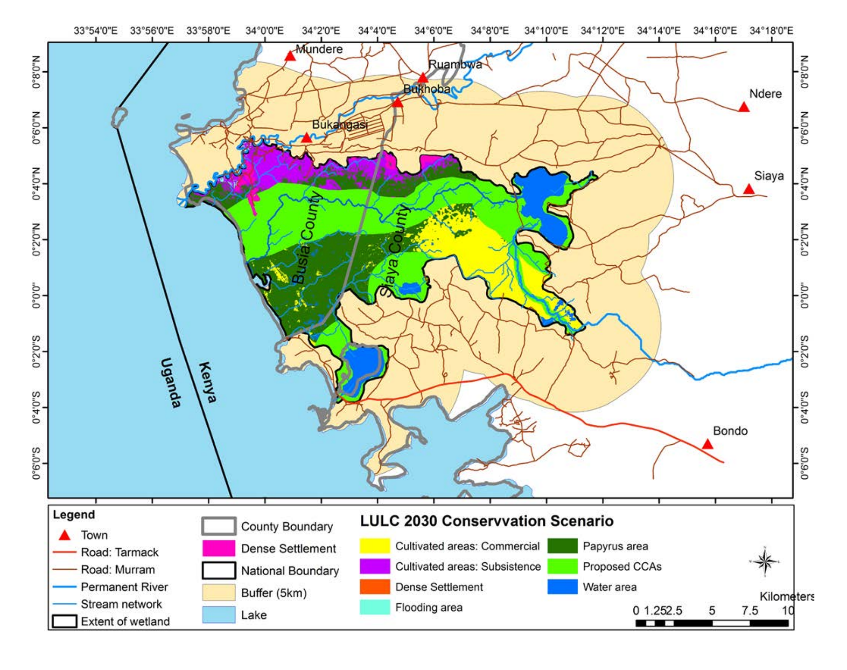
Land use/cover in Yala wetland by 2030 in the Balanced Development
Scenario. Source

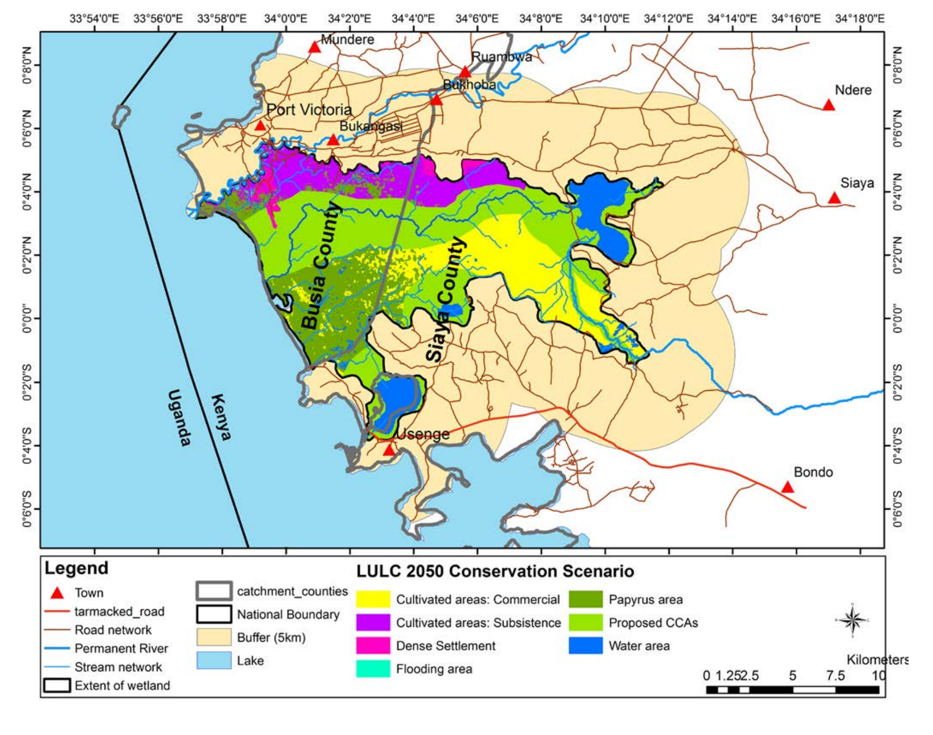
Land use/cover in Yala wetland by 2050 in the Balanced Development
Scenario. Source

How can T-labs be used to steer transformation towards equitable and sustainable developments in wetlands?
A Transformation Laboratory (T-lab) is a participatory and transdisciplinary process that creates a safe space that cultivates creativity and innovation among stakeholders to address a complex problem. T-labs are specifically designed to guide transformations in socio-ecological systems towards sustainability, by supporting changes in the conditions that made these systems unsustainable. They include a set of stakeholders who may have different roles and perspectives, but who have an interest in solving the problem and some ability to provoke change.
T-labs aim to produce socio-ecological innovations that help to create a more just and sustainable outcome for people and other parts of nature.
In the context of Yala and Kingwal wetlands in Kenya, T-labs can play a crucial role in guiding the development of equitable and sustainable pathways for wetland management in various ways. First, inclusive pathways through engaging a wide range of stakeholders such as the local communities, government agencies, non-governmental organizations, researchers and other relevant participants is important to collectively define the challenges and opportunities associated with wetland management. In this instance, T-labs can also help in framing the problems associated with wetland degradation in a way that considers ecological, social, economic and equity dimensions. This involves identifying the root causes and interconnections among issues.
Secondly, the T-lab supports different suites of methodologies such as visioning exercises to understand the problem andhelps all the stakeholders in the wetlands have a shared use/value. Using scenario planning techniques, stakeholders can explore different future scenarios for wetland utilisation; how they would like the wetlands to be or look like in future, where they are now, and how they are going to get there. This helps the stakeholders to understand the possible consequences of different pathways and enables them to think beyond the day-to-day reality of problem solving and imagine an achievable medium to long-term future.
Thirdly, T-labs enable innovation and generation of solutions by providing a space for brainstorming and co-designing innovative solutions; with examples of sustainable agricultural practices, alternative livelihood options and various conservation strategies. Based on insights generated, policy and institutional reforms can then be formulated, which could involve strengthening existing laws or proposing new regulations that address the specific challenges faced by the wetlands.
T-Labs can be further used for capacity building and community empowerment by identifying capacity gaps among stakeholders and developing strategies for knowledge sharing, especially within the local communities that depend on the wetlands. This could involve providing local communities’ training that would also allow for indigenous knowledge integration, enabling access to resources, and providing a platform for them to actively participate in decision making processes to ensure that traditional knowledge and local priorities are considered for preservation of cultural and ecological values.
Moreover, adaptive management can help in recognizing the dynamic nature of wetland ecosystems and the uncertainties due to climate change. T-labs should then be able to provide approaches and strategies that are flexible and responsive to changing conditions. Monitoring and evaluation frameworks can be developed to track progress towards the desired outcome in indicators related to equity, sustainability and biodiversity conservation.
T-labs are therefore a powerful tool for steering transformation towards equitable and sustainable developments in wetlands like those in the Yala River Basin. They enable collaborative problem solving, innovation and co-creation of pathways that balance the needs of people as well as the environment. Through this, T-Labs guides transformations through supporting changes in the conditions that made these systems inequitable and unsustainable towards equity and sustainability. However, the success relies on inclusivity and continuous engagement of all relevant stakeholders.
The team successfully held the first T-lab for the Yala wetland in November 2023 where a visioning exercise was conducted with participants framing the challenge collectively and identifying initiatives that are emerging and are “seeds” that could be nurtured to address the challenges identified. For Kingwal wetland, the first T-lab workshop will be held in early April 2024. The outcome of these workshops will be published in a separate blog.
Problem policy brief, which is the first output of the Transpath project under Stream 1(Transdisciplinary research on cases) activities, for the two wetlands will be developed by December 2024.

are geographical units created by the 2010 Constitution of Kenya as the new units of devolved government.

